Ideation Phase

Brainstorm & Idea Prioritization Template
Date | 02 July 2026
Team ID | __________
Project Name | Sports Hall Booking System using Service Portal (ServiceNow)
Maximum Marks | 4 Marks

Brainstorm & Idea Prioritization Template
Brainstorming enables the project team to exchange ideas and identify practical solutions for managing sports hall reservations digitally. Every team member is encouraged to contribute innovative suggestions that improve the booking experience, simplify hall management, and increase operational efficiency.
This brainstorming activity helps the team evaluate multiple approaches, organize similar ideas, and select the most suitable features before starting development in the ServiceNow Service Portal. The final outcome ensures that the project addresses both user requirements and administrative needs effectively.

Step-1: Team Gathering, Collaboration and Select the Problem Statement
Use this structured format to define exactly what your ServiceNow application aims to solve.
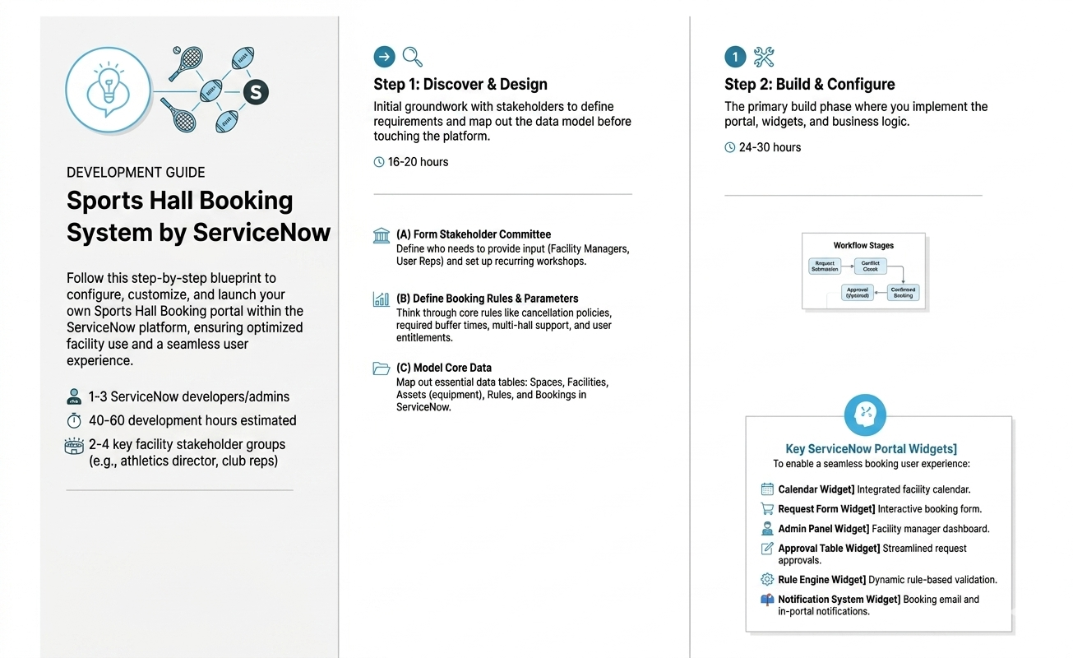

Step-2: Brainstorm, Idea Listing and Grouping

all features your team wants into one big list without judging them first. You then sort those chaotic ideas into five organized buckets—UX, Booking, Approvals, Admin, and Security—so your ServiceNow developers know exactly what to build.
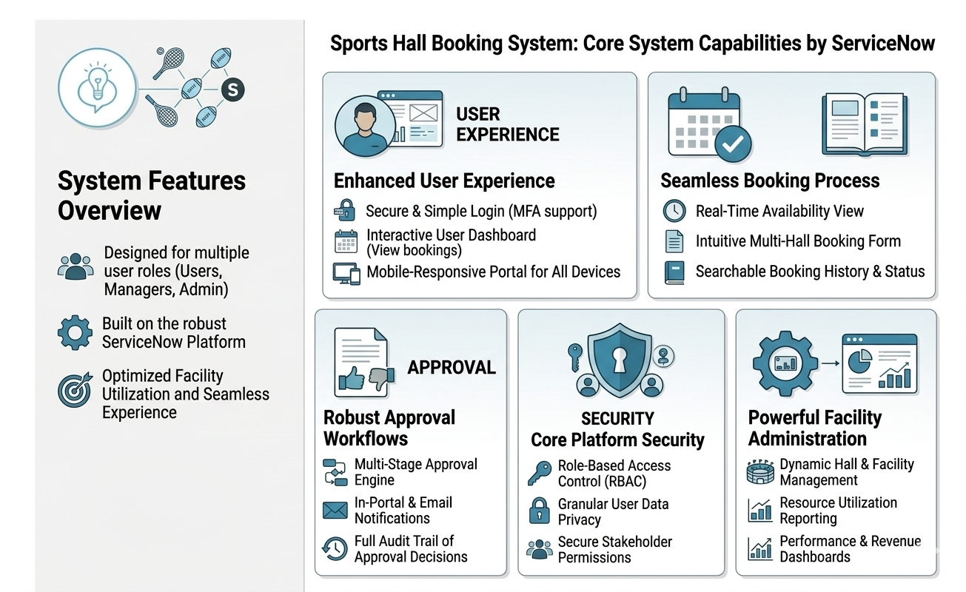

Step-3: Idea Prioritization
